Name :Dhanashri Rode
Roll.No 49
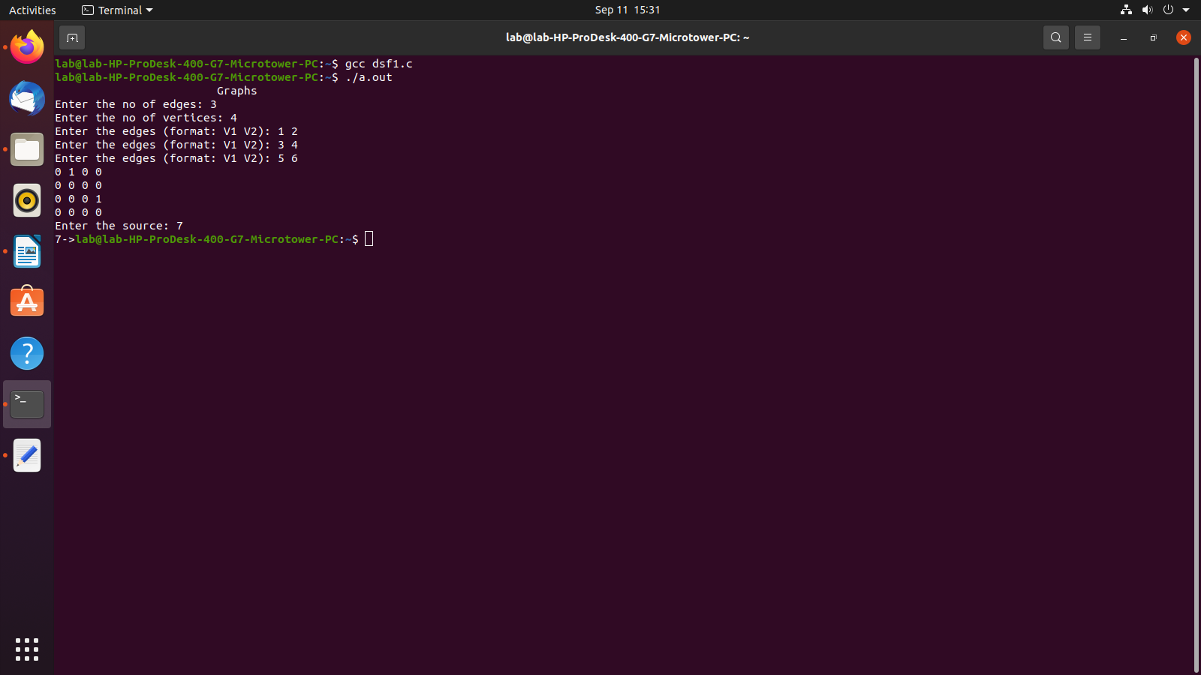

#include <stdio.h>
#include <stdlib.h>

int source,V,E, time, visited [20], G[20][20];
void DFS(int i)
{
int j;
visited[i]=1;
printf("%d->",i+1);
for(j=0;j<V; j++)
{
if(G[i][j]==1&&visited[j]==0)
DFS(j);
}
}
int main() {
int i,j,v1, v2;
printf("\t\t\tGraphs\n");
printf("Enter the no of edges: ");
scanf("%d", &E);
printf("Enter the no of vertices: ");
scanf("%d", &V);
for(i=0;i<V;i++)
{
for(j=0;j<V; j++) {
G[i][j]=0;
}
}
for(i=0;i<E;i++)
{

printf("Enter the edges (format: V1 V2): ");
scanf("%d %d", &v1,&v2);
G[v1-1][v2-1]=1;
}
for(i=0;i<V;i++)
{
for(j=0;j<V; j++)
{printf("%d ",G[i][j]);
}printf("\n");
}
printf("Enter the source: ");
scanf("%d", &source);
DFS(source-1);
return 0;
}

